SET A
- 0 (No Days)

- 1 - 2 Days

- 3 - 4 Days

- 5/More Days

SET B
- Strongly Disagree
- Disagree
- Disagree a Little
- Agree a Little
- Agree
- Strongly Agree

SET C
- Not At All
- A Little
- Moderately
- A Lot
- A Great Deal
SET D
1) Rarely or none of the time (Less than 1 day)
2) Some or little of the time (1 - 2 Days)
3) Occasionally or a moderate amount of time (3
- 4 Days)
4) All of the time (5 - 7 Days)
SET E
1) Needs no help (No Supervision)
2) Needs Some Help (Some Supervision)
3) Needs a lot of Help (Constant Supervision)
4) Cannot Do it At All

All rights reserved © 2018 TCARE, Inc. Side 1 | Response Card

SET F
- Definitely not
- Probably not
- Probably would
- Definitely would
- Does not apply — relative is in care facility
SET H
- Acting as a [RELATIVE] almost all the time
- Acting most often as a [RELATIVE] but sometimes you are a CAREGIVER
- Acting equally as a [RELATIVE] and as a CAREGIVER
- Acting most often as a CAREGIVER but sometimes you are a [RELATIVE]
- Acting as a CAREGIVER almost all the time
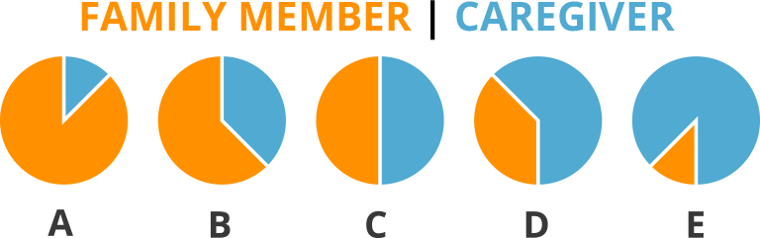
SET G
All rights reserved © 2018 TCARE, Inc. Side 2 | Response Card

